Participant Portal Guide
- What is organisation registration?
- How to register an organisation
- How will the organisation be validated - Centralised or Decentralised?
- Differences between Centralised and Decentralised during registration process
- How to register an organisation
- What to do if a similar organisation is found
- How to add a document
- Modify Organisation

What is organisation registration?
To participate in proposals and projects, you must register your organisation first. After registration, a unique identifier is assigned to your organisation. This is the 9-digit PIC (Participant Identification Code) number that will be used as a reference by the Commission in any future interactions.
A single registration is required for each organisation in the system. The use of a PIC for each organisation helps to avoid misusage of funds by non-reliable parties and facilitates the effort to keep participant-related information up-to-date.
Please keep the legal data of the organisation and programme related information at hand. You can check the information you will need for the registration in the documentation of the call for proposals. Please note that you have to register your organisation before submitting a project application.
You can pause the registration process at any time and continue it later. The system automatically saves your draft registration and will keep it until you complete it or for up to one year after its last edit.
Access to URF is found here - http://ec.europa.eu/education/participants/portal/desktop/en/home.html

If you are a new user, you must create an EU Login account before registering. You will find details on the URF website.

How to register an organisation
The registration procedure is performed in the URF Registration Wizard – a step-by-step, user-friendly tool for entry of all the information required for an organisation to be registered. The URF Registration Wizard is invoked from the Participant Portal page when a new registration is started or when a draft (partially completed and saved) registration is resumed. The URF Registration Wizard displays any possible duplicate organisations during the registration process.

How will the organisation be validated - Centralised or Decentralised?
All organisations for Creative Europe, Erasmus+, Europe for Citizens and EU Aid Volunteers, once they register their organisations, may use the PIC to submit their application. Depending on which agency is handing their application request,
- Centralised: the organisation may be validated in URF (validation by REA (Research Executive Agency), in Brussels).
or
- Decentralised: will be validated in the National Agency project management system, in the different participating countries of the programme (validation by National Agency).
If an organisation applies for a HE accreditation, the organisation will not go through centralised validation, unless it goes forwards and applies for a grant request managed by EACEA (Education, Audiovisual and Culture Executive Agency), in Brussels.
If an organisation applies for VET, EVS and HE mobility consortia accreditation, the organisation will go through validation in the National Agency project management system.

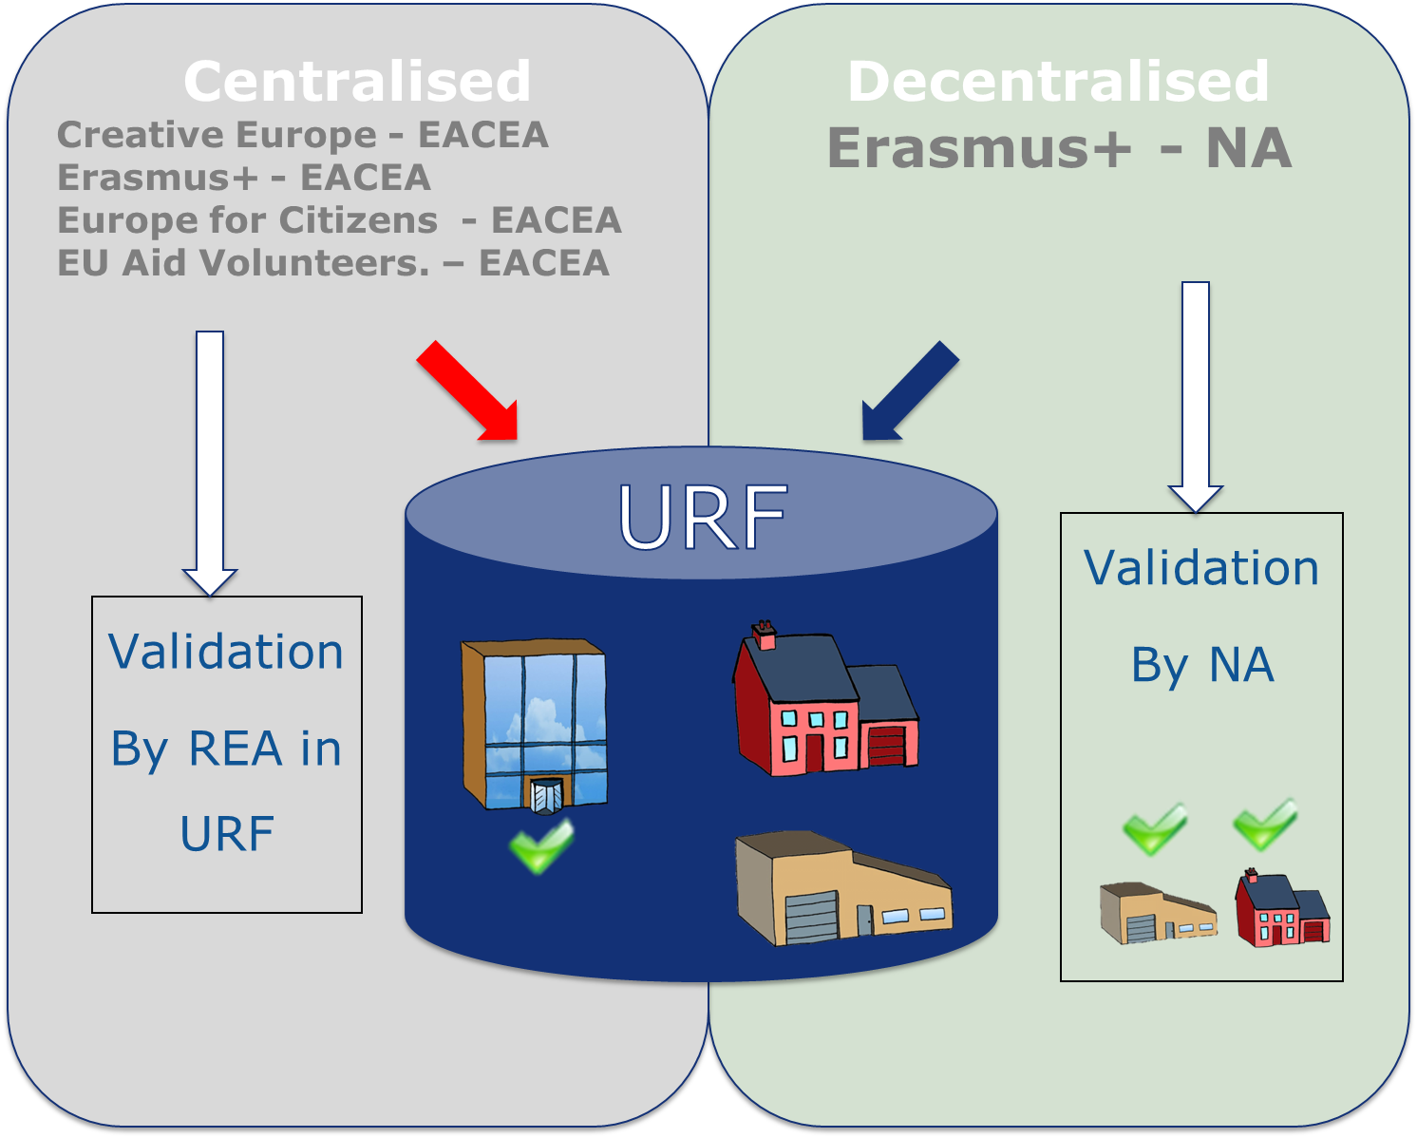

Differences between Centralised and Decentralised during registration process
If your organisation is selected for the projects managed by EACEA (centralised projects) then your organisation will need to pass a Legal Entity validation, nominate a LEAR and your organisation will have to provide supporting legal documents. In that case, the mandatory fields for the LEAR needs to be filled.
The mandatory fields for the LEAR (Legal Entity Appointed Representative) contact details do not have to be completed if you are submitting your application for an Erasmus+ project to a National Agency (decentralised projects).
To know if the form specific to each project is to be submitted to the National Agencies (specific for decentralised Actions) or to the Executive Agency (specific for centralised Actions), see in the Programme Guide – section General Eligibility Criteria – point Where to Apply for each Action.

How to register an organisation

This section explains how to register an organisation in URF.

Quick steps
- 1 Login to URF using your EU Login (previously ECAS) account
- 2 Sign in to "EU Login" (previously ECAS) account
- 3 Register for an EU Login account if you don't have one
  - 3.1 Click the "Create an account" hyperlink
- 4 Register your organisation
  - 4.1 Go to "Organisations" and then select "Register".
  - 4.2 Click on "Register Organisation".
  - 4.3 Click on "Next".
  - 4.4 Fill in the organisation's "Identification" details and click on "Next".
  - 4.5 Complete the "Organisation" details.
  - 4.6 Fill in "Contact" details and click on "Next".
  - 4.7 Review the summary of details entered.
  - 4.8 The 9 digit Participant Identification Code (PIC) is displayed.

Detailed steps

Steps

Login to URF using your EU Login (previously ECAS) account
Open the Participant Portal and click on LOGIN.
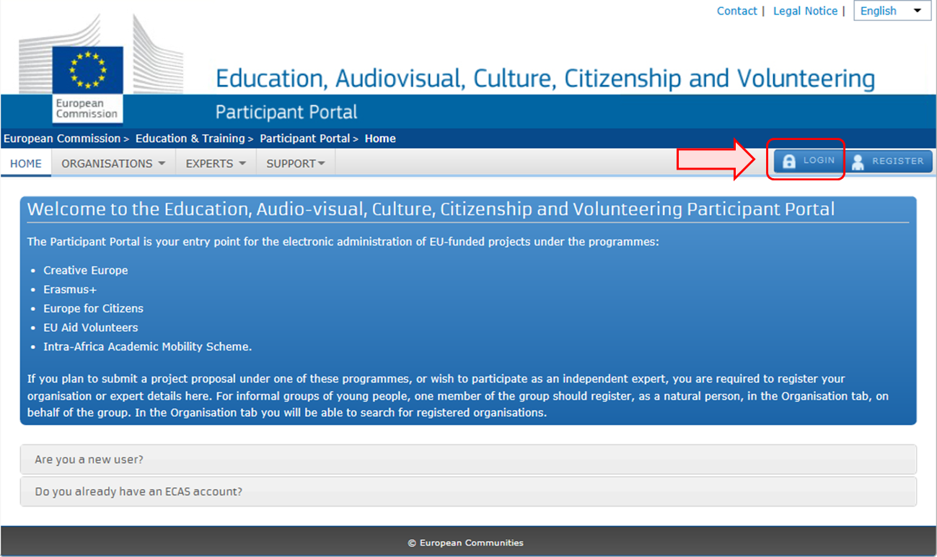

Sign in to "EU Login" (previously ECAS) account
Enter your institution's e-mail address in order to sign in. This must be the same e-mail address provided by you while creating your EU Login (previously ECAS) account. The message informing you of your access is sent to this address.
After entering the e-mail, click on the Next button.

Once clicking on Next, a new screen will be displayed:
- You will see your e-mail address displayed on the screen.
- Enter your password.
- You can choose a different Verification method. The EU Login allows a verification mechanism based on multi-factors (i.e. Mobile phone + SMS, Token, EU Login or ECAS Mobile App). Make sure you have added the devices to your account if you wish to use an alternative authentication than e-mail.
- After entering your password, click on the Sign in button.

Register for an EU Login account if you don't have one

Click the "Create an account" hyperlink
In order to create a new account, click on the Create an account hyperlink.
If you already have an ECAS account, you don't have to create a new EU Login account. In EU Login, your credentials and personal data remain unchanged. You can still access the same services and applications as before. You just need to use your e-mail address for logging in.

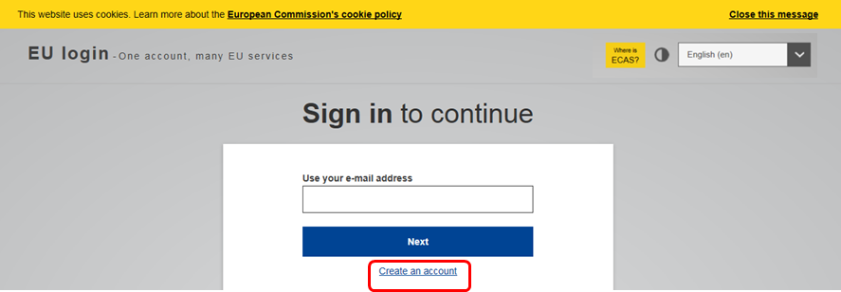

Register your organisation

Go to "Organisations" and then select "Register".
Once you have logged-in, click on Register in the ORGANISATIONS drop-down menu in order to register your organisation.
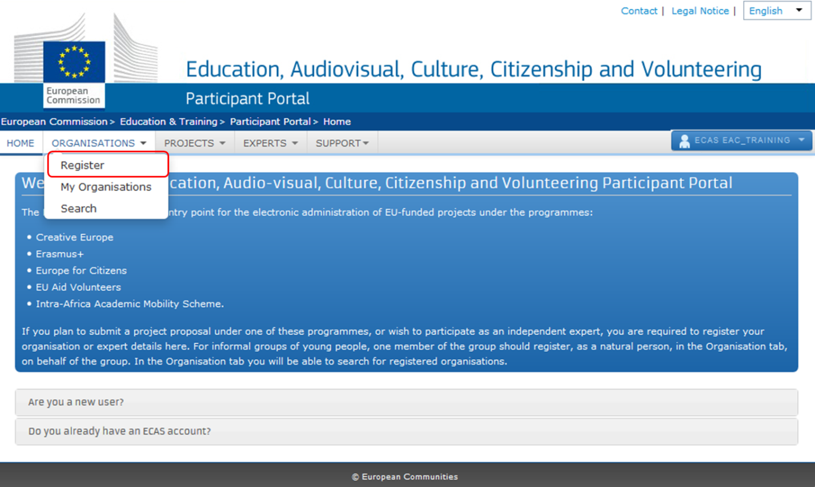

Click on "Register Organisation".
Click on REGISTER ORGANISATION in order to proceed with the registration.
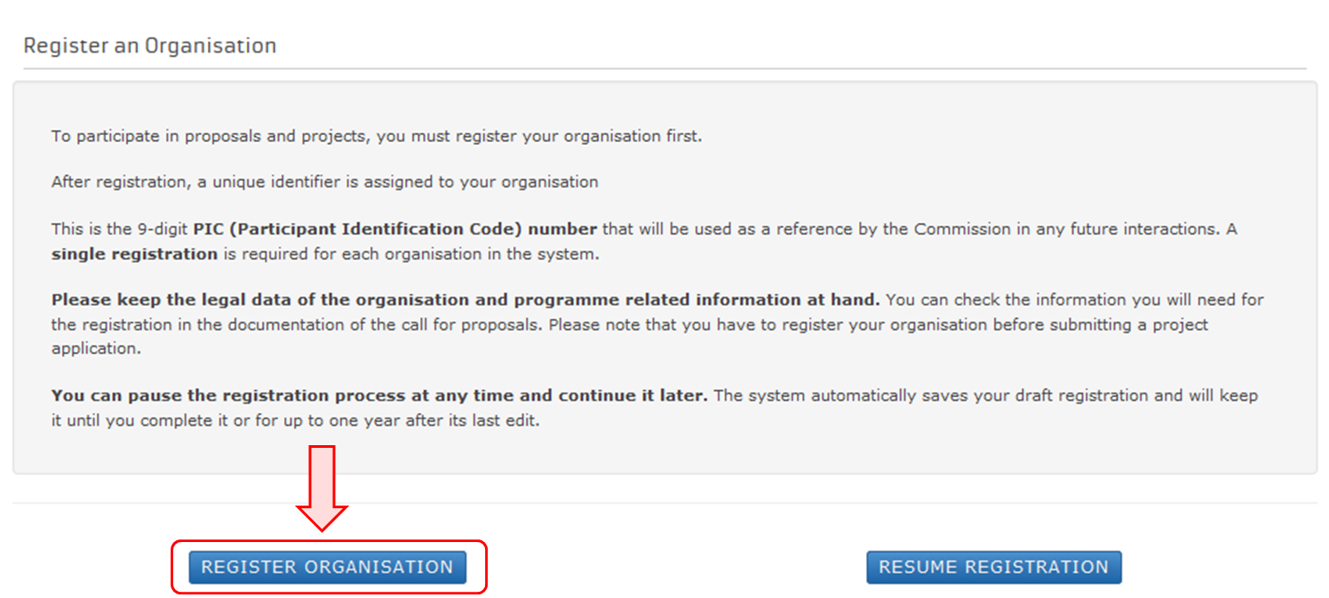

Click on "Next".
A new window tab opens displaying a Welcome message and brief explanation of the registration process.
Click on Next > at the bottom right of the screen in order to start the registration or in order to continue your existing registration.
Note that you can pause the registration process at any time and continue it later.
The system automatically saves your draft registration and will keep it until you complete it or for up to one year after its last edit.
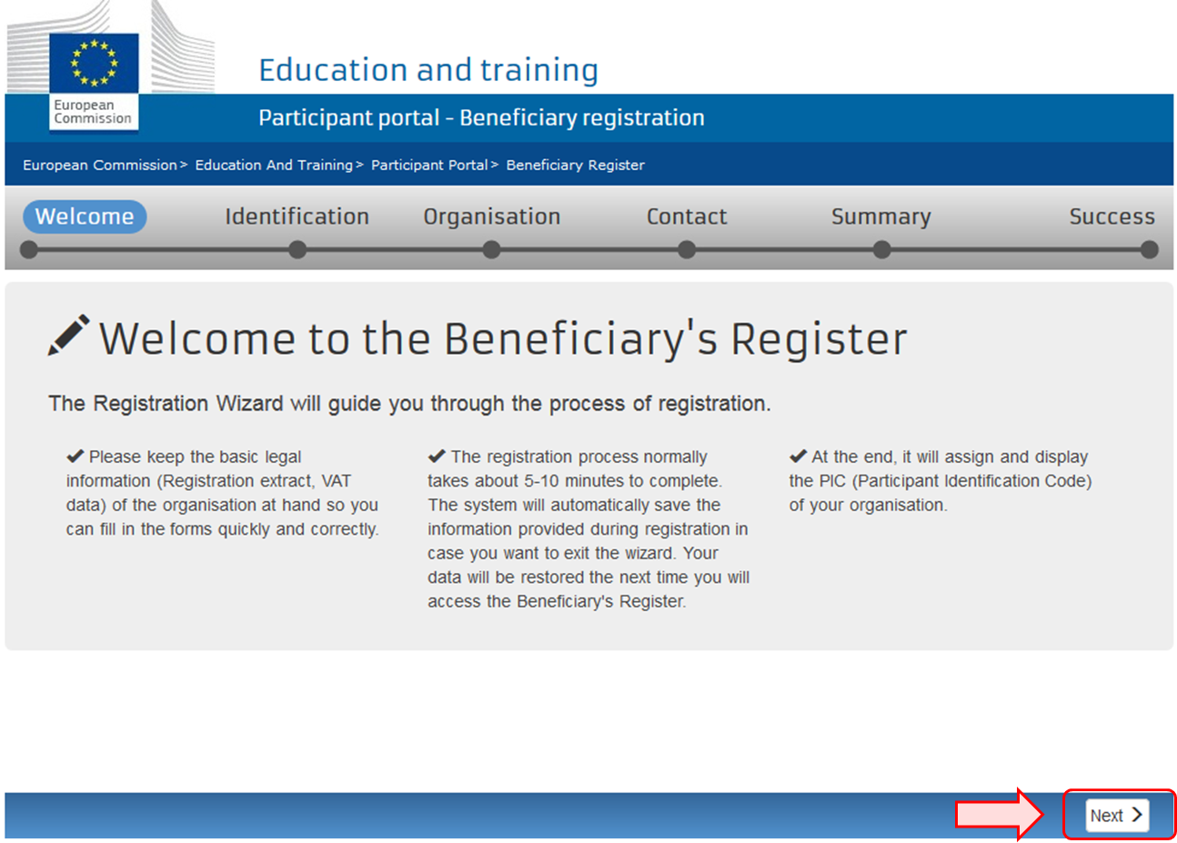
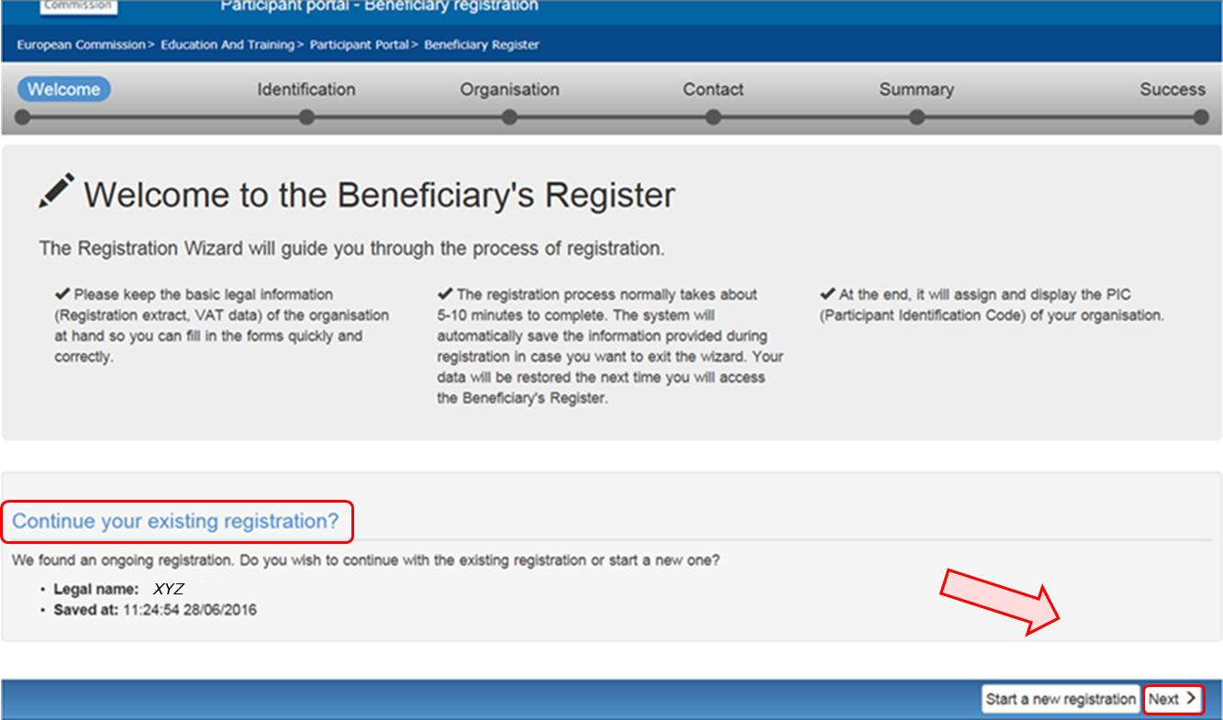

Fill in the organisation's "Identification" details and click on "Next".
Fill in the mandatory fields in the Identification screen and click on Next > at the bottom right of the screen in order to proceed to the next step.
You can click on the blue i icons in order to reveal more information about the fields.
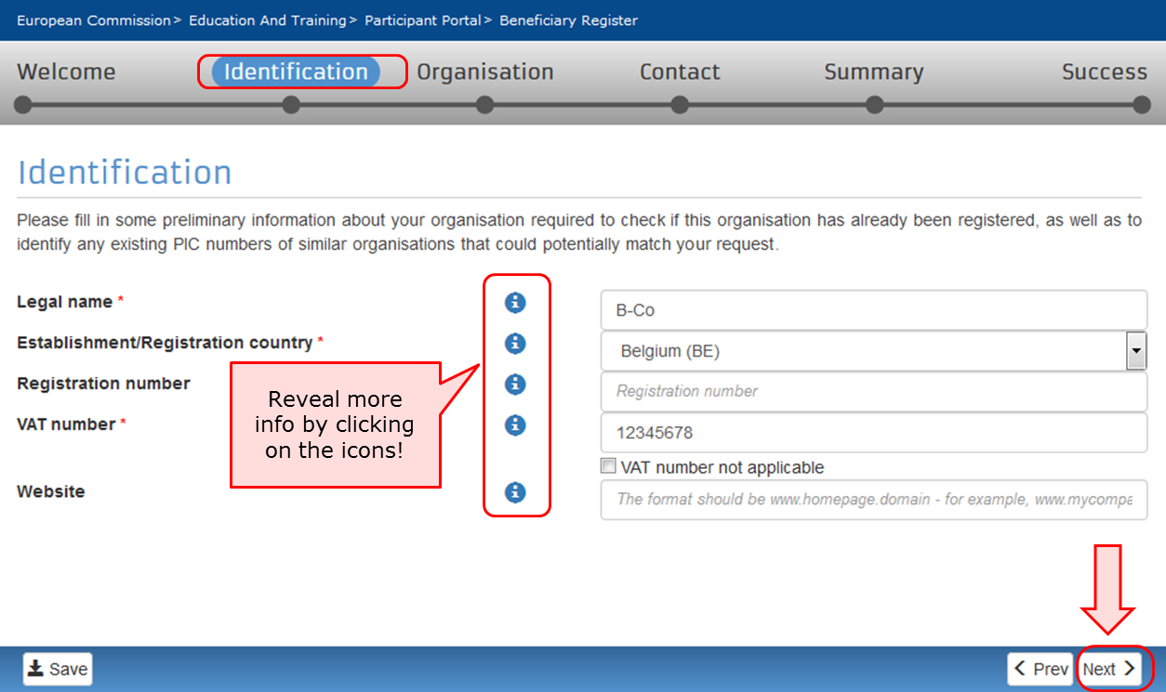

Complete the "Organisation" details.
In the Organisation screen fill in the information regarding the Legal name and status, Registration data and Legal Address.
Click on Next > at the bottom right of the screen in order to proceed to the next step.
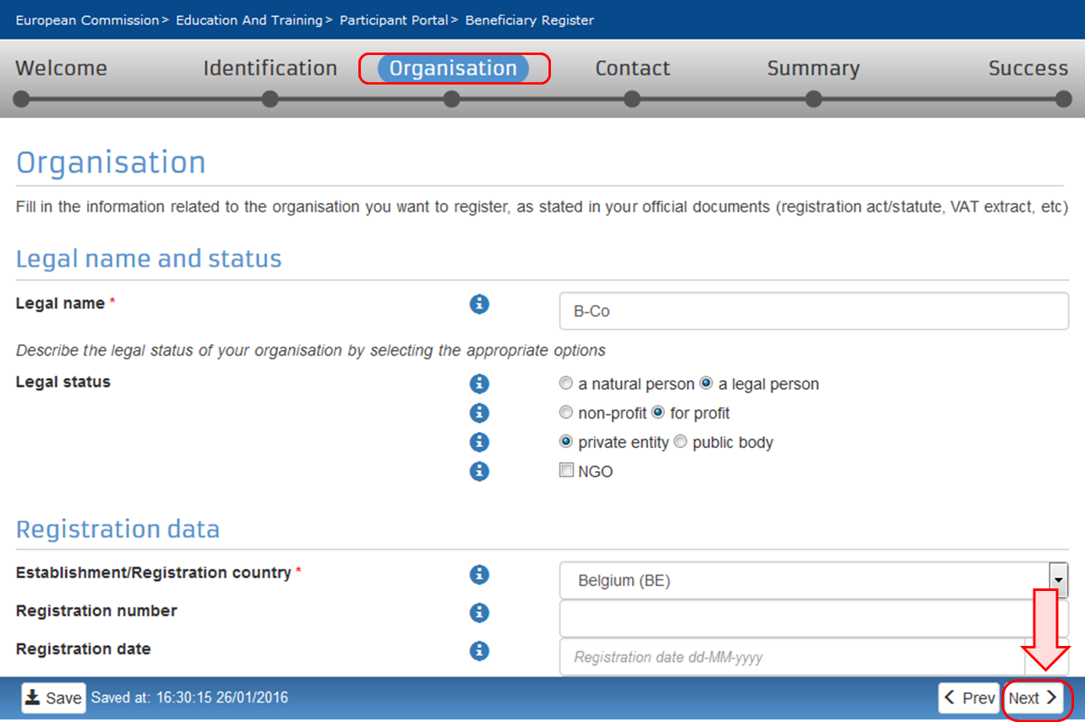

Fill in "Contact" details and click on "Next".
Fill in the details in the Contact screen. These details will be used to contact and send notifications about the actions to be done.
If a different contact is to be indicated other than the self-registrant (person who is logged in via ECAS and who is currently registering the organisation), then do this by checking the No box to the question at the top of the contact person section. Then fill in the contact person details.
Note that you can copy the existing organisation's address and phone numbers as entered in the Organisation screen by checking the Yes box.
New organisations registered in EU countries and other countries included in the list, will not be able to register without providing a valid Post Code.
For these specific countries, only Postal Codes respecting a specific format will be accepted.
Whenever a Regular expression is not foreseen (countries not included in the list) also empty Post Codes are accepted.
Only Post Code for "Legal address" of the organisation are mandatory.
No direct relationship is enforced between Post Code and Region it is the responsibility of the registering organisation to insure coherence.
Click on Next > at the bottom right of the screen in order to proceed to the next step.
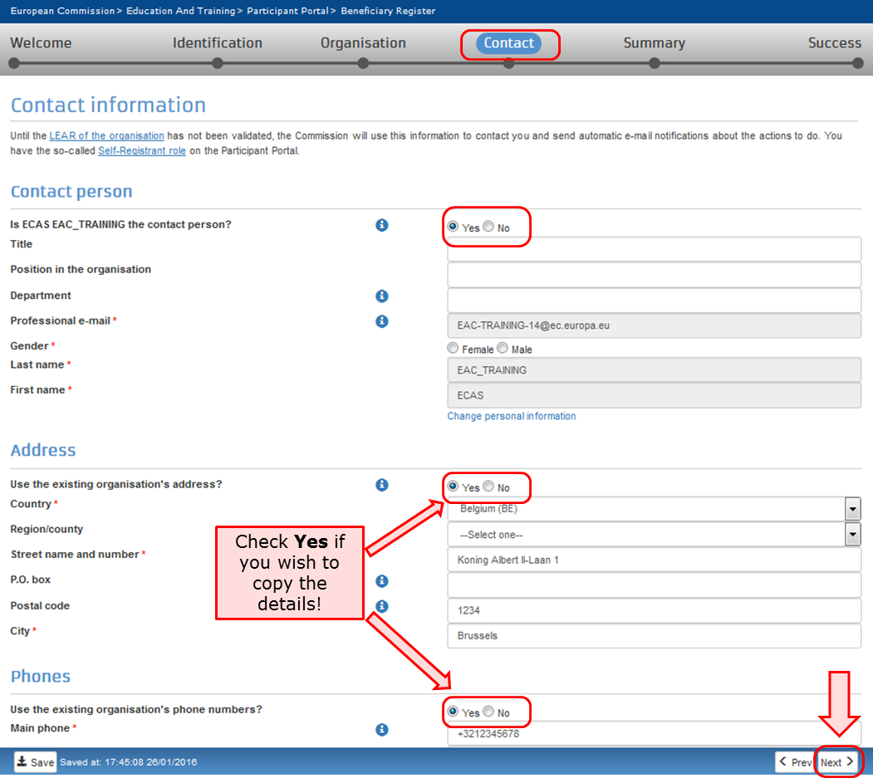

Review the summary of details entered.
A Summary screen will open. Review the information provided and click on Edit if any changes should be introduced.
Once you have reviewed the details, click on Submit at the bottom right of the screen in order to complete your registration.
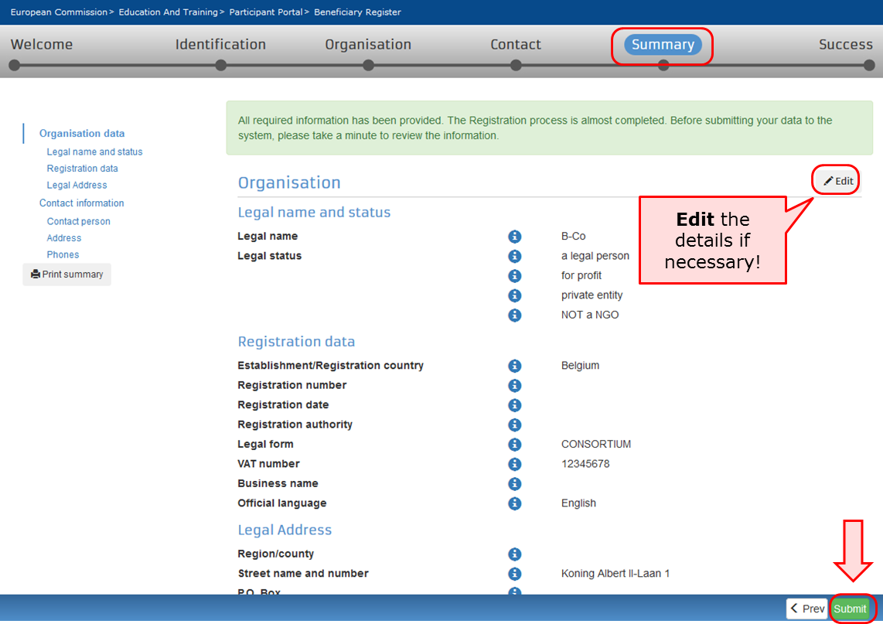

The 9 digit Participant Identification Code (PIC) is displayed.
A Success screen will open informing that the registration has been completed and the system will provide you with your organisation's PIC number.
Now you are ready to submit your application using the generated PIC.
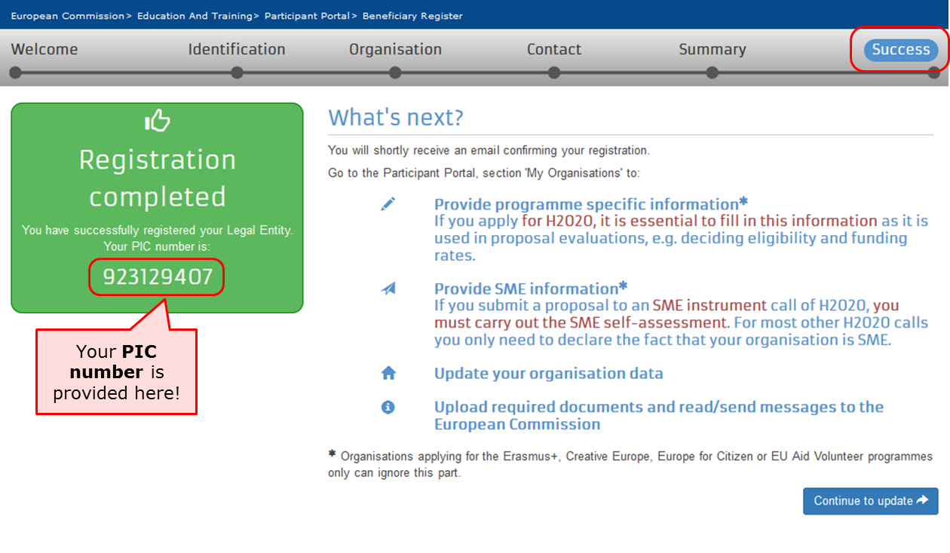

What to do if a similar organisation is found
This page explains how to proceed if during the registration process the system notifies you that a similar organisation already exists in the Beneficiary Register.
- Analyse your data.
- Proceed if not relevant.
- "Contact Organisation" to use PIC.

Analyse your data.
Explanation and illustration
At the Identification step of your registration process you might get notified that a similar organisation already exists in the Beneficiary Register. Click on the blue tabs in order to expand the details and analyse the organisation data.
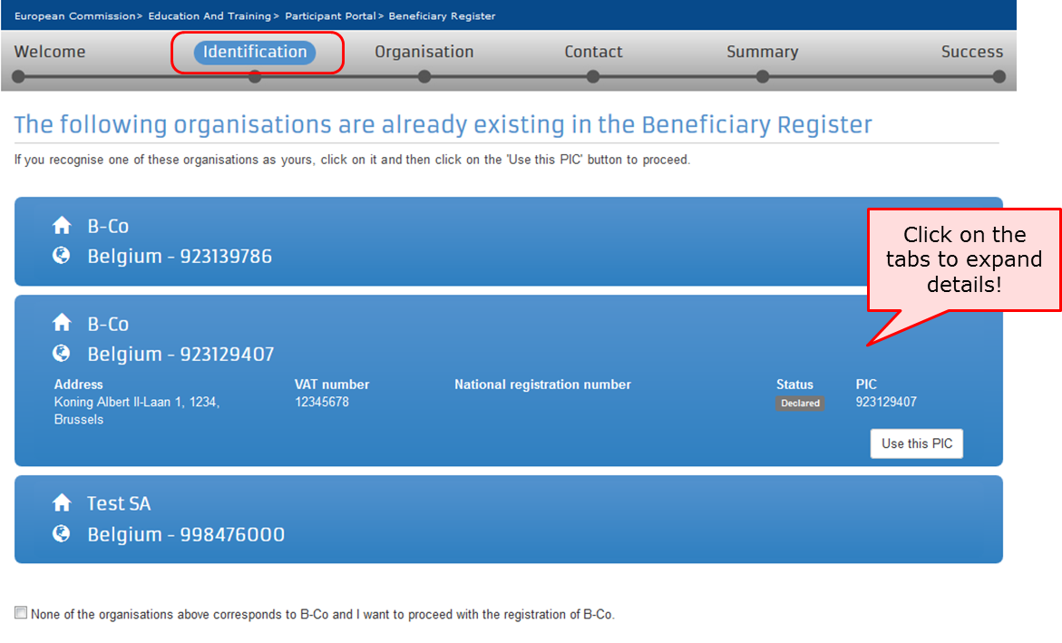

Proceed if not relevant.
Explanation and illustration
If none of the organisations listed corresponds to your organisation, check the box below the list and click on the Next > in order to proceed with the registration as normal.
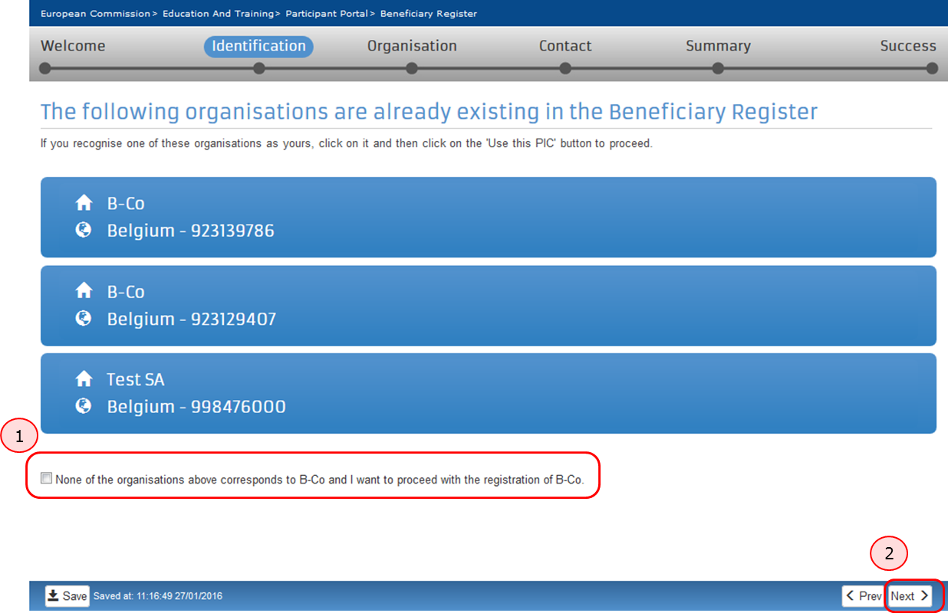

"Contact Organisation" to use PIC.
Explanation and illustration
If you recognise the organisation as yours, first click on the Use this PIC in order to proceed. A Use this PIC window will open.
If your organisation data is correct and no modifications are needed you can already use the PIC number in the application form you may want to submit. If modifications are needed, only the contact person of your organisation (or the LEAR in some cases) can do them.
To verify, who is responsible within your organisation, and to ensure that the latest documentation can be updated to the PIC details, click on Contact Organisation. This will open the Send message window, allowing you to write a message to the contact person of the organisation. You may also seek this contact person inside your organisation by any other means at your disposal through internal channels.
Please note, if the contact person has left the organisation or if the email address associated to the contact details is incorrect, the system will not notify you. In this case it is advisable to contact your local National Agency. They will be able to inform you of the contact details for your organisation in URF.
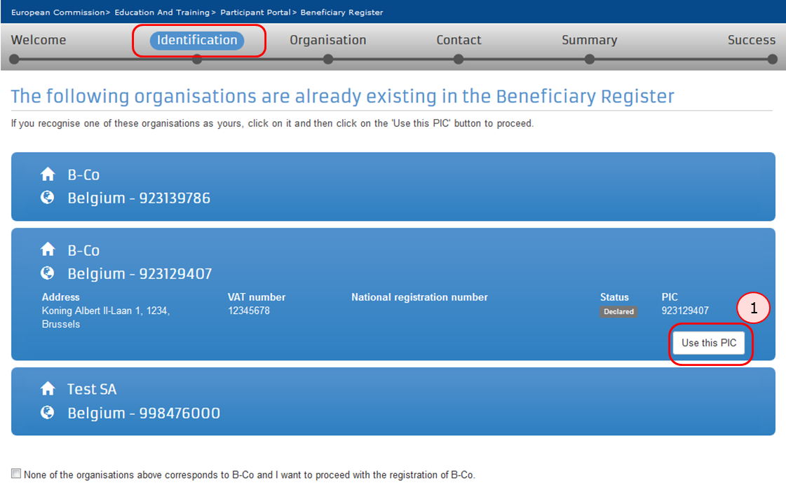
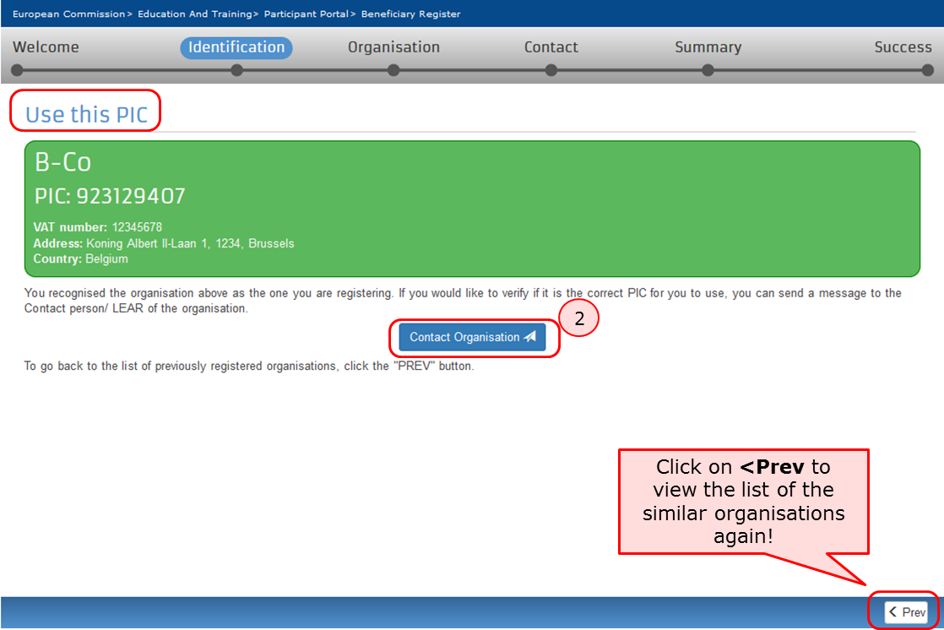
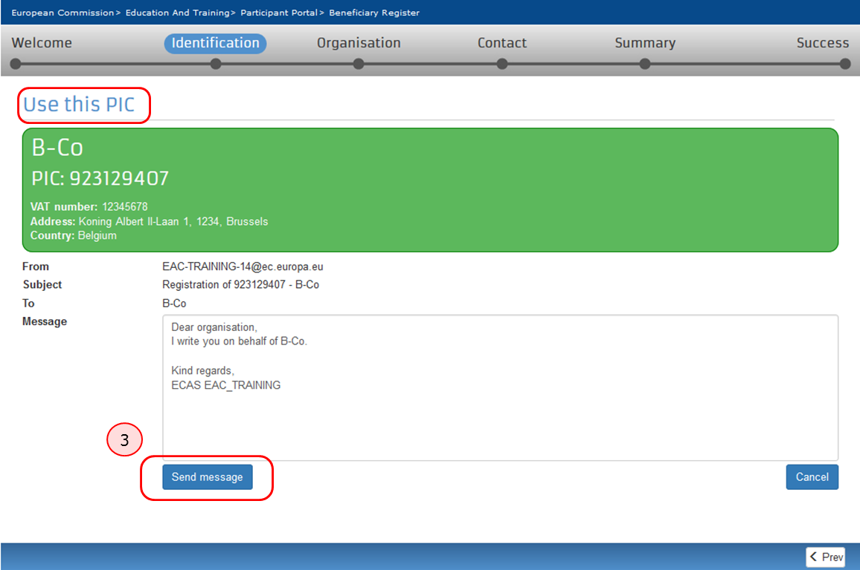

How to add a document
The steps explained here will open the same screen to update the organisation details as if you had selected to Continue to update after registering the organisation.

Quick steps
- 1 Click on "My Organisations".
- 2 Click on "MO" icon to modify.
- 3 Add a document in the "Documents" section.
  - 3.1 Click on "Add document".
  - 3.2 Select a file to upload.
  - 3.3 Close browser window - no need to click on "Submit changes".

Detailed steps
Steps

Click on "My Organisations".
After the organisation is registered, you can modify the organisation's details at any stage. From the Participant's Portal homepage, click on My Organisations in the ORGANISATIONS drop-down menu.
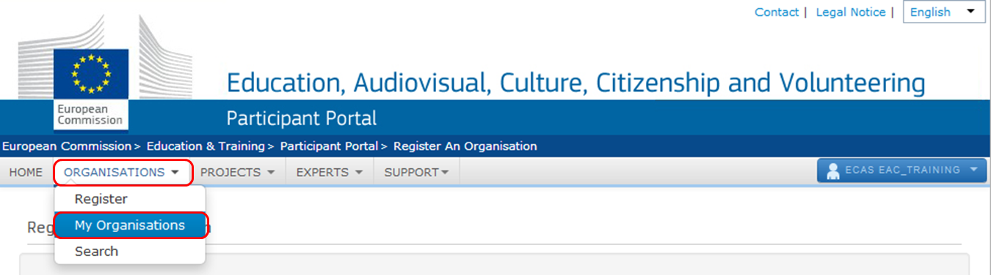

Click on "MO" icon to modify.
My organisations screen will open. Click on the MO icon in order to Modify Organisations.
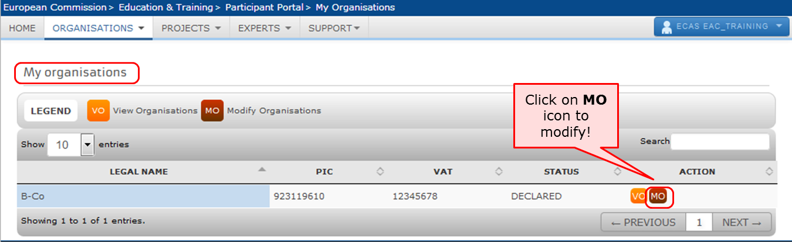

Add a document in the "Documents" section.
The window will open in a new browser tab allowing you to view and modify the data of your organisation. You can either click on Documents at the top left corner of the screen or scroll down to the Documents section manually.
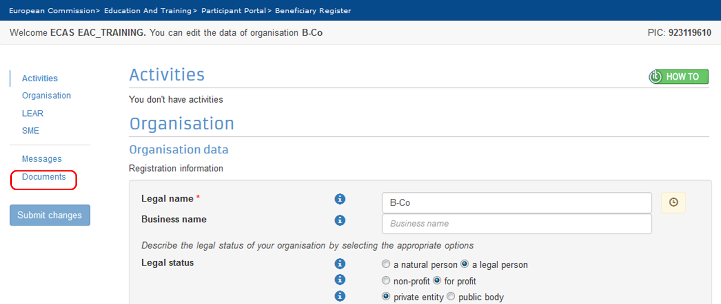

Click on "Add document".
Note that the maximum allowed document size is 6MB.
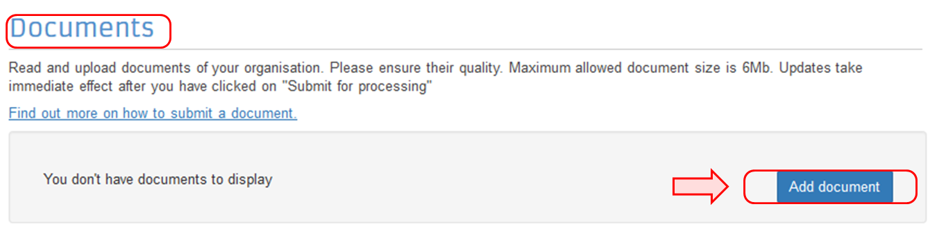

Select a file to upload.
The section will expand allowing you to Select a file. Once selected, indicate the Document type from the drop-down list. You can also add a Description and check the box to specify that the document has been submitted in Original language. After that, click on Submit for processing. Note that once uploaded, the document type may not be withdrawn or modified but a new version of that type of document may be added.
Note that the hyperlink to Find out more on how to submit a document is not entirely relevant for organisations that would like to submit a project under one of the following programmes: Creative Europe, Erasmus+, Europe for Citizens or EU Aid Volunteers, therefore it is not recommended to click on the link.
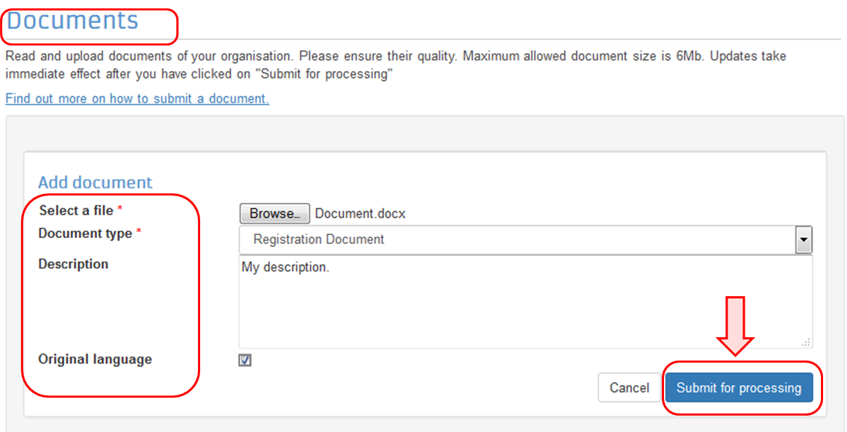
Now the document has been submitted and will have a status Received. You can click on the Document type label (in the example below the type is Registration Document) to expand the details of the document or to replace the submitted document with a new version.
No further actions are required and you can close the window session.
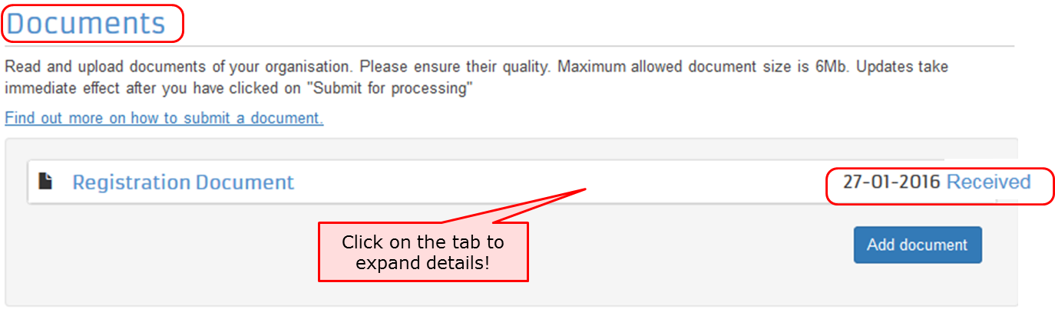

Close browser window - no need to click on "Submit changes".
The document uploaded has been saved and no further information requires to be entered on this screen to complete this action.
The Submit Changes button does not have to be clicked in order for the document to be submitted. The browser window can be closed and the documents uploaded are saved without further actions.
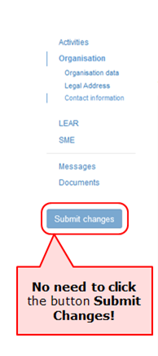

Modify Organisation
Organisation details, which are registered in the participant portal, may require to be modified at any stage.
There might be different scenarios when an organisation needs to modify data of organisation:
- Modifications of organisation's details - for both Declared and Validated PICs
- Change of the contact person
- Give access to documents
- Change of Organisation as a result of splitting, regrouping or merge - Without and with HEI Accreditation
Whether the data is modified for centrally validated PICs (i.e. validated by REA) or the data is modified for locally validated PICs (i.e. validated by your National Agency), the modifications will be done directly in Education & Training Participant Portal.Click on the hyperlink or the MO button to modify data.
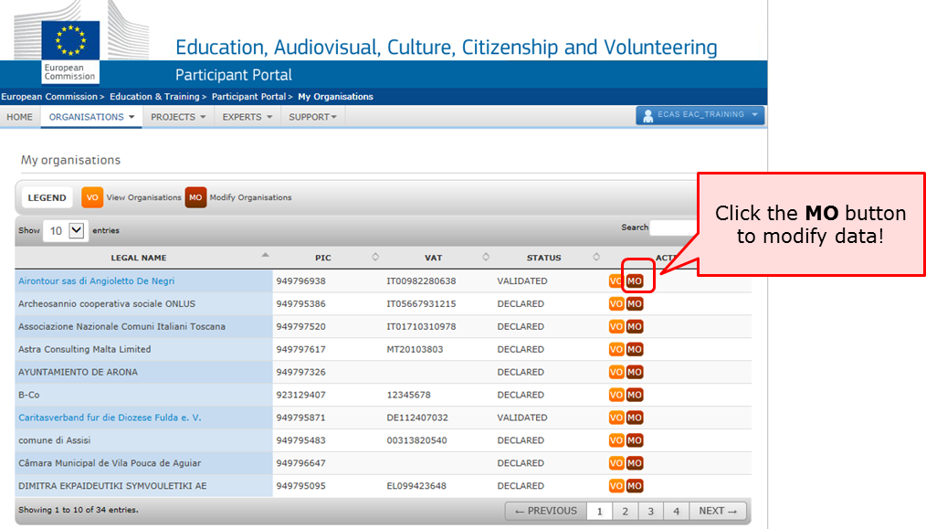

There can be different statuses of PIC in PDM/URF:
- DECLARED: Organisation registered in PDM/URF by self-registrant.
- VALIDATED: Organisation validated centrally by REA.
- SUSPENDED: Change in the organisation (e.g. merge, split), need to suspend the obsolete organisations.
- SLEEPING: When the contact person does not react on any demands from the validation team.
- DEPRECATED: Marked as obsolete, usually in case of duplicates and the master PIC is filled in.
- BLOCKED: The legal entity is "frozen" due to an external reason (Bankruptcy, etc.)

Modify Organisation - Declared and Sleeping PIC (status in PDM/URF)
Error rendering macro 'excerpt-include' : User 'kvedavi' does not have permission to view the page 'Modify Organisation - Declared and Sleeping PIC (status in PDM/URF)'.

Modify Organisation - URF Centrally validated PIC
Whenever there is a change, the organisation needs to update the data in PDM/URF. If the PIC is validated centrally, REA needs to validate the organisation's change request before the data can be saved and used in an application form or applied in the application/project information in the National Agencies project management system.
If the PIC has been centrally validated and you require to modify the organisation, you can do it in the same way as explained in the section: URF - Modify Organisation.

Change Contact person - Declared PIC
The context of this process impacts organisations with Declared PIC with a self-registrant and contact person and without a Legal Entity Appointed Representative (LEAR). Declared PICs are assigned to organisations that go through decentralised validation done by National Agency. Declared PICs usually have one contact person with the rights to update the organisation data. In most cases the self-registrant and the contact person are the same person, unless the self-registrant registers on behalf of someone else.
Please note, that the Contact person in URF is not the same person as the Preferred Contact person indicated in the Application form. For those projects that have been selected and awarded, see how to manage contacts in the Mobility Tool here.
When the contact person leaves the organisation without appointing another person, the access to update the PIC is lost. An organization can always request password reset, however this only works when the person forgets the password. If the person left the organisation, in most cases, the organisation does not have access to the email address any longer so a password rest will not help. Therefore, it is recommended for each organisation to have at least two people with access to PIC to ensure a backup.
In order to request to change the contact person that was registered in PDM/URF, a beneficiary should contact the NA, informing the full name and email of the new contact person.
There is a first step to check the organisation data, leading to two scenarios:
A) If the contact person is the same as the self-registrant, the NA proceeds with the request to update the organisation's data to the new contact person directly in PDM/URF.
B) If the contact person is different from the self-registrant, the NA will inform the self-registrant contact details to the beneficiary.
The beneficiary then contacts the self-registrant to request them to add a different contact person. The self-registrant adds in PDM/URF the new contact person, who will be from now on the person, who makes changes in the organisation's data.
For the self-registrant to add a contact person, the self-registrant logs into the participant portal and performs the following steps.

- 1 Click on "My Organisations".
- 2 Click on "MO" icon to modify.
- 3 Change the self-registrant role to another contact person
  - 3.1 Select "No"
  - 3.2 Add in the contact details
  - 3.3 Click on "Submit changes"
  - 3.4 Confirm the changes by clicking on "Submit changes"
Steps

Click on "My Organisations".
After the organisation is registered, you can modify the organisation's details at any stage. From the Participant's Portal homepage, click on My Organisations in the ORGANISATIONS drop-down menu.

Click on "MO" icon to modify.
My organisations screen will open. Click on the MO icon in order to Modify Organisations.

Change the self-registrant role to another contact person
In the section Contact information, the self-registrant is indicated as Helen Doyle. The self-registrant is indicated also as the contact person. This can be seen by the answer Yes to the question Is Helen Doyle the contact person?. Helen Doyle's contact details have been copied from EU Login (previously ECAS) to the contact details fields.
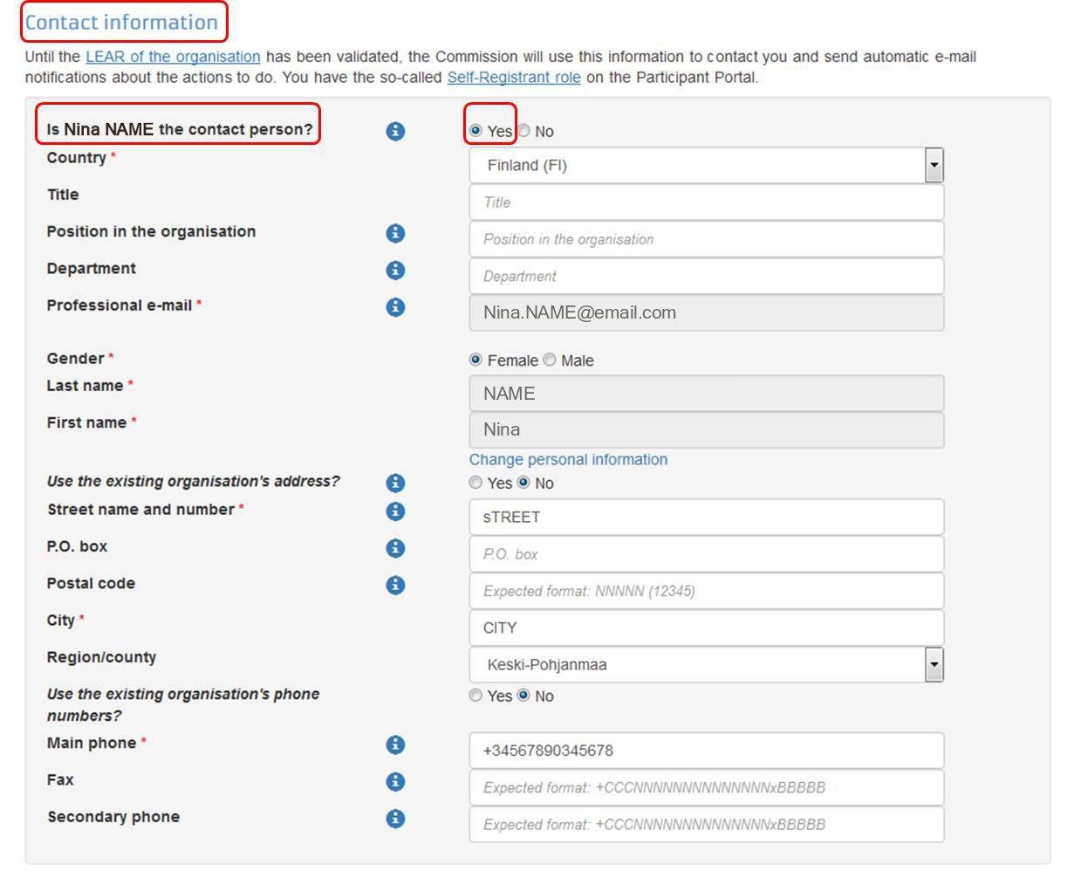

Select "No"
If a different contact is to be indicated other than the self-registrant, then do this by answering No to the question Is Helen Doyle the contact person?.
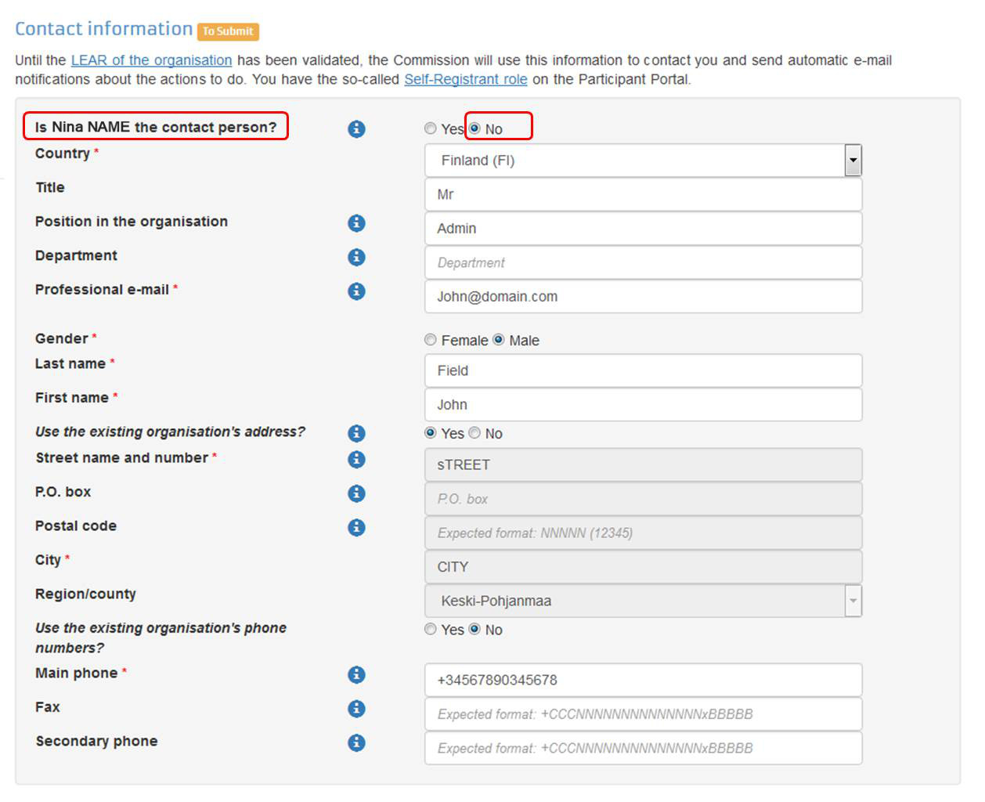

Add in the contact details
Fill in the details of the new contact person.
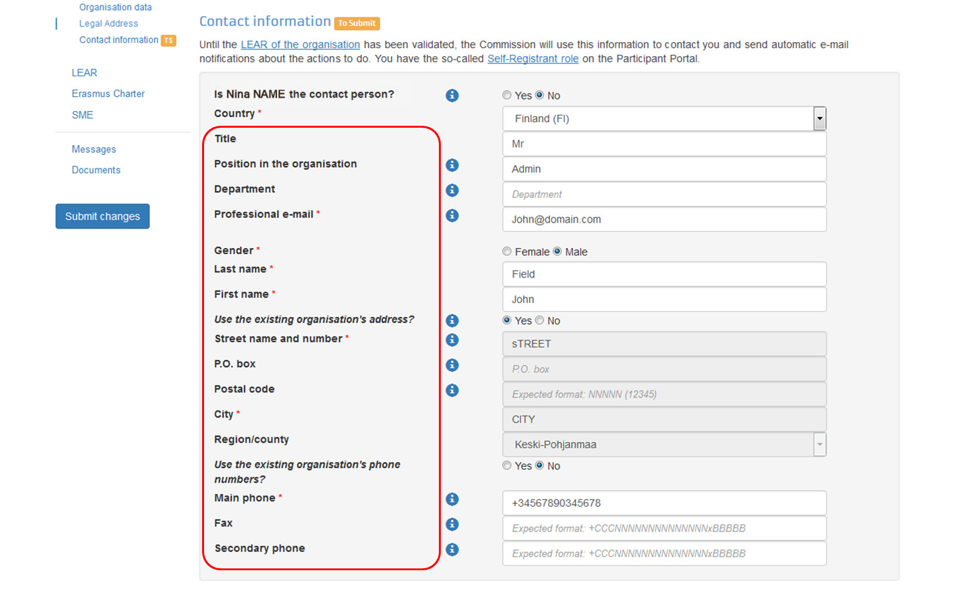

Click on "Submit changes"
After all the mandatory fields have been filled in, click the Submit changes button on the left-hand side of the screen.
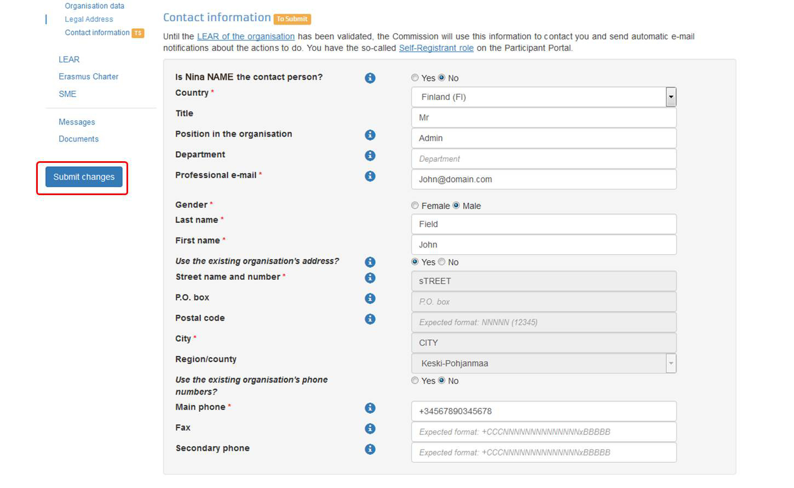

Confirm the changes by clicking on "Submit changes"
A pop-up message will appear, summarising the data groups you have modified. Confirm your changes by clicking the Submit changes button.
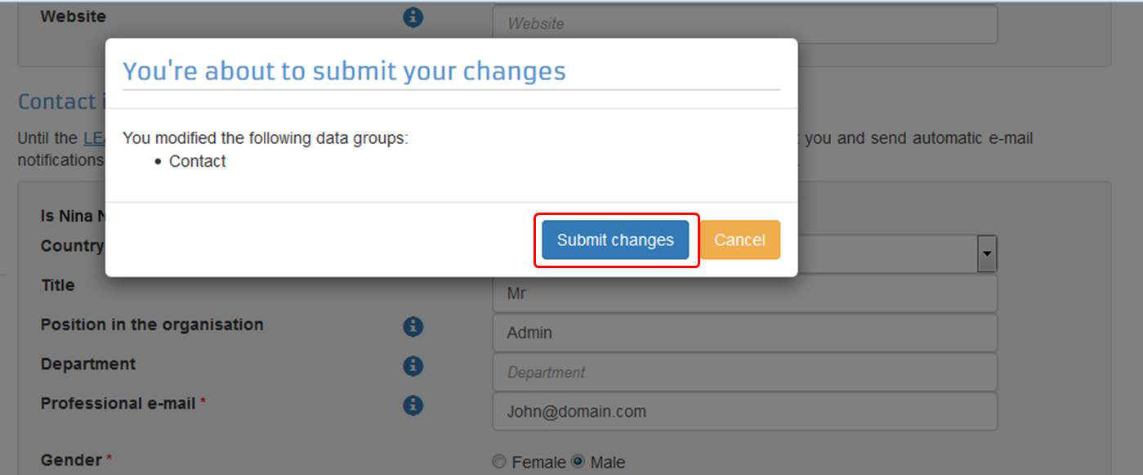

Give Access to Documents - Declared PIC
In rare cases, PICs that were registered centrally, do not display the documents in the National Agency's project management system. The NA may ask the beneficiary to confirm that the documents were actually added. Once the NA has confirmed that the documents are correctly uploaded in URF, the NA can request to reset the access to the documents so the NA can proceed to validate the organisation.

Change Organisation due to regrouping, splitting or absorption - Without Accreditation
- 1 Summary (a new PIC is created and existing PICs remain).
- 2 Organisations are regrouped into new one (a new PIC is created).
- 3 Organisations are merged/absorbed into one (an existing PIC is updated).
- 4 Organisation is Split.

Summary (a new PIC is created and existing PICs remain).
In summary, these are the main activities in case a change of the status of an organisation without accreditation:
- The organisation registers (for New organisations) or modifies (modify organisation validated by NAs for decentralised actions or modify organisation validated centrally) the organisation's details (for Existing organisations) in the Participant Portal.
- If it is a new organisation, the organisation submits a grant application form outside the annual call. Once completed, submit to the NA in PDF form. The form is filled based on internal agreement between the organisations on how they intend to share the budget and mobilities. The new project will be created in the NA management system and the NA will create the budget for the new project. If it is an existing organisation, the organisation needs to notify the NA about the organisation update and if applicable to any changes to arrangements of the budget and mobilities between the projects. The NA will update the budget in their management system. The NA will send the latest project data to MT+, thereby updating the organisation information and current approved budget in MT+.
- The organisation (new registration or modified registration) will be validated by the NA and/or REA. REA follows its own validation process. The NA will check if the data registered in URF corresponds to the organisation's legal data as set out in the supporting documents uploaded in the tool.
- A grant agreement will be signed with the new organisation. For existing organisations, the NA creates an amendment to the grant agreement due to the budget change of existing project or depending on the type of change in organisation detail.
- The beneficiary needs to move mobilities in MT+ from the original projects to the new ones:
  - Add partner organisations if applicable;
  - Export list of mobilities from original project;
  - Change the project reference in the mobilities list exported from the project to be terminated.
  - Change the organisation ID to that of the remaining project organisation ID for each PIC.
  - Ensure that the Participant ID or mobility ID do not overlap with the existing mobilities in the remaining project.
  - Import into new project.
- The new organisation sends a message to their partners to update the PIC in MT+.
- If applicable, the beneficiary should reassign OLS licenses to reflect the changes in the current budget overview in MT+.
- If the change leads to obsolete or absorbed organisations, the NA terminates the project of the obsolete institution.

Definitions:
Existing organisation: An existing (or part of an) institution continues existing after a change, which can be regrouping, splitting or absorption.
New organisation: A new institution (new legal status) is founded that regroups former institutions after a change, e.g. regrouping, splitting or absorption.
Validated by REA: Modified data of organisation previously validated by REA or submiting project to centralised actions.
Validated by NA: Modified data of organisation not yet validated by REA and submitting project to decentralised actions.

Please, note that REA is only involved in the process to validate applicants of centralised actions.
See also: How will the organisation be validated - Centralised or Decentralised?

For specific scenarios, refer to the common identified cases in change of status of organisations listed below:

Organisations are regrouped into new one (a new PIC is created).

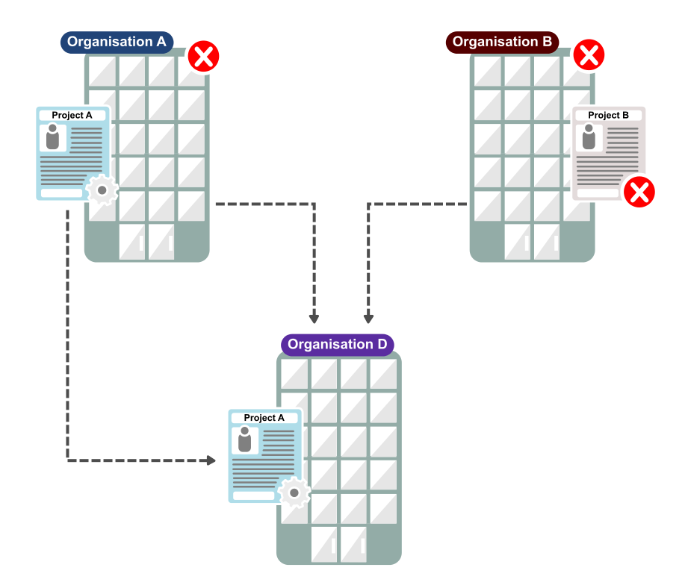

Scenario
In the scenario where two organisations are regrouped into a new organisation, a new PIC is created with the latest information in the participant portal. The obsolete PIC should be invalidated (centrally or not centrally).
If the regrouping is partial and parts of the organisations continue to exist, it leads to a new PIC and existing PICs: apply the same steps as in the Summary.
The scenario is applicable where the organisation is the coordinating organisation of the project.

During selection
In this case if there is an application process running for each PIC: Please, inform your NA to update one application request with the new PIC and budgetary information if required, while the other application is rejected. During the selection process the new organisation will be validated and linked to the obsolete ones, thereby invalidating them. In the case of central validation by REA, this process must first be finalised by REA before the new organisation will appear as validated in the National Agency project management system.

Project is awarded and grant agreement signed
- Register the new organisation in the Participant Portal.
- The new organisation submits a grant application form outside the annual call. Once completed, submit to the NA in PDF form. The form is filled based on internal agreement between the organisations on how they intend to share the budget and mobilities. The new project will be created in the NA management system and the NA will create the budget for the new project. The NA will send the latest project data to MT+, thereby updating the organisation information and current approved budget in MT+.
- The new organisation will be validated by the NA and/or REA. REA follows its own validation process. The NA will check if the data registered in URF corresponds to the organisation's legal data as set out in the supporting documents uploaded in the tool.
- A grant agreement will be signed with the new organisation.
- The beneficiary needs to move mobilities in MT+ from the original projects to the new ones:
  - Add partner organisations if applicable;
  - Export list of mobilities from original project;
  - Change the project reference in the mobilities list exported from the project to be terminated.
  - Change the organisation ID to that of the remaining project organisation ID for each PIC.
  - Ensure that the Participant ID or mobility ID do not overlap with the existing mobilities in the remaining project.
  - Import into new project.
- The new organisation sends a message to their partners to update the PIC in MT+.
- If applicable, the beneficiary should reassign OLS licenses to reflect the changes in the current budget overview in MT+.
- The NA terminates the project of the obsolete or absorbed institutions.

Organisations are merged/absorbed into one (an existing PIC is updated).

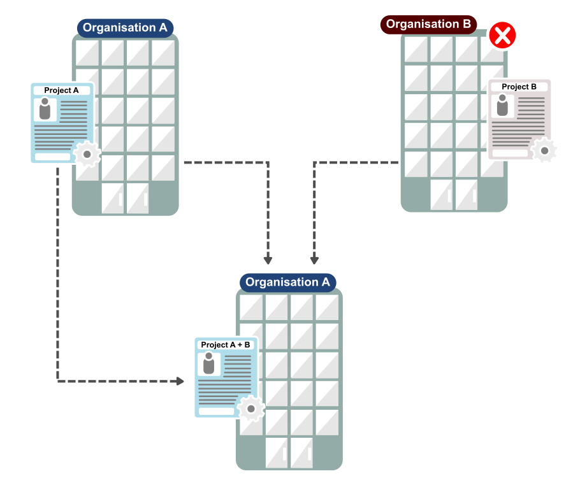

Scenario
In the scenario where two organisation are merged into one, the existing PIC of one may be updated with the latest information in the participant portal (URF). The obsolete PIC should be invalidated (centrally or not centrally).

During selection
In this case, if there is an application process running for each PIC: After updating information in URF, inform your NA to update one application request with the latest project and budgetary information while the other project is rejected. During the selection process, the existing PIC will be linked to the obsolete PIC and thereby invalidating it (if not done centrally by REA).

Project is awarded and grant agreement signed
- The organisation modifies (modify organisation validated by NAs for decentralised actions or modify organisation validated centrally) the organisation's details (for Existing organisations) in the Participant Portal.
- The organisation needs to notify the NA about the organisation update and if applicable to any changes to arrangements of the budget and mobilities between the projects. The NA will update the budget in their management system. The NA will send the latest project data to MT+, thereby updating the organisation information and current approved budget in MT+.
- The organisation (with modified registration) will be validated by the NA and/or REA. REA follows its own validation process. The NA will check if the data registered in URF corresponds to the organisation's legal data as set out in the supporting documents uploaded in the tool.
- The NA creates an amendment to the grant agreement due to the budget change of existing project or depending on the type of change in organisation detail.
- The beneficiary needs to move the mobilities in the Mobility Tool+ from the original projects to the new one (see steps in Summary).
- If applicable, the beneficiary should reassign OLS licenses to reflect the changes in the current budget overview in MT+.
- The NA terminates the project of the obsolete or absorbed institutions.

Organisation is Split.
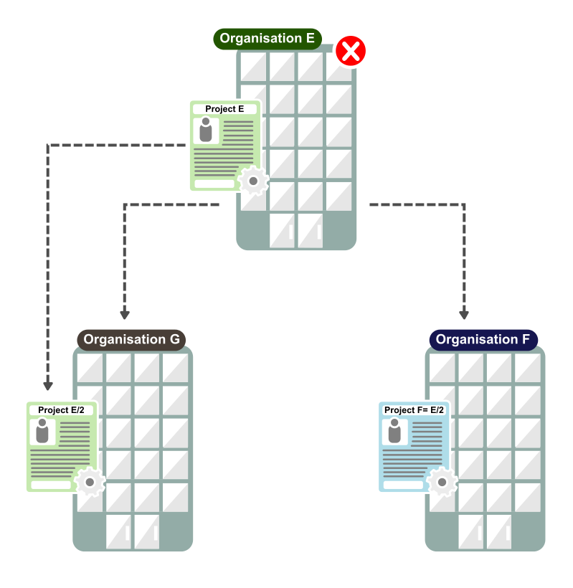

Scenario
In this scenario, one organisation is split into two. The existing PIC may be updated in URF and one new PIC is created.This is the same as explained in the Summary.

During selection
In this case, if there is an application process running for one PIC: After updating information in URF, inform your NA to update the existing application request with the latest project and budgetary information. A new application may be submitted. If outside the the annual call, request the grant application form outside the annual call from your National Agency. Once completed, submit to the NA in PDF form.

Project is awarded and grant agreement signed

- The organisation registers (for New organisations) or modifies (modify organisation validated by NAs for decentralised actions or modify organisation validated centrally) the organisation's details (for Existing organisations) in the Participant Portal.
- If it is a new organisation, the organisation submits a grant application form outside the annual call. Once completed, submit to the NA in PDF form. The form is filled based on internal agreement between the organisations on how they intend to share the budget and mobilities. The new project will be created in the NA management system and the NA will create the budget for the new project. If it is an existing organisation, the organisation needs to notify the NA about the organisation update and if applicable to any changes to arrangements of the budget and mobilities between the projects. The NA will update the budget in their management system. The NA will send the latest project data to MT+, thereby updating the organisation information and current approved budget in MT+.
- The organisation (new registration or modified registration) will be validated by the NA and/or REA. REA follows its own validation process. The NA will check if the data registered in URF corresponds to the organisation's legal data as set out in the supporting documents uploaded in the tool.
- A grant agreement will be signed with the new organisation. For existing organisations, the NA creates an amendment to the grant agreement due to the budget change of existing project or depending on the type of change in organisation detail.
- The beneficiary needs to move mobilities in MT+ from the original projects to the new ones:
  - Add partner organisations if applicable;
  - Export list of mobilities from original project;
  - Change the project reference in the mobilities list exported from the project to be terminated.
  - Change the organisation ID to that of the remaining project organisation ID for each PIC.
  - Ensure that the Participant ID or mobility ID do not overlap with the existing mobilities in the remaining project.
  - Import into new project.
- The new organisation sends a message to their partners to update the PIC in MT+.
- If applicable, the beneficiary should reassign OLS licenses to reflect the changes in the current budget overview in MT+.
- If the change leads to obsolete or absorbed organisations, the NA terminates the project of the obsolete institution.
When the organisation becomes obsolete in the result of regrouping or splitting, the NA will terminate the grant agreement with obsolete HEI in MT+.

Change Organisation status - with HEI Accreditation

When a change of the status concerns an organisation with an HEI accreditation:
- The organisation registers (for New organisations) or modifies (modify organisation validated by NAs for decentralised actions or modify organisation validated centrally) the organisation's details (for Existing organisations) in the Participant Portal.
- The organisation fills in change request form "institutional profile – change of status of the higher education institution", informing the contact details of the new Erasmus coordinators including the new PIC and the underlying official documents, and send it to the NA.
- The NA will check the eligibility of the institution in cooperation with their National Authority (NAU). NAUs check whether a given institution can be considered as an HEI eligible for participation in Erasmus+, according to their national legislation.
- Now the change request form can be verified by the NA and sent to EACEA for evaluation. For new organisations, EACEA has 5 calendar days to evaluate the request form. For existing organisations, the PIC and Erasmus code are maintained.
- EACEA will issue new Erasmus codes and attribute transitory accreditation to the new organisation.
- EACEA sends a note to the HEI, and in copy the NA, on the attribution of the transitory charter, its validity end-date and the new Erasmus ID code.
- If it is a new organisation, the organisation submits a grant application form outside the annual call. Once completed, submit to the NA in PDF form. The form is filled based on internal agreement between the organisations on how they intend to share the budget and mobilities. The new project will be created in the NA management system and the NA will create the budget for the new project. If it is an existing organisation, the organisation needs to notify the NA about the organisation update and if applicable to any changes to arrangements of the budget and mobilities between the projects. The NA will update the budget in their management system. The NA will send the latest project data to MT+, thereby updating the organisation information and current approved budget in MT+.
- The organisation (new registration or modified registration) will be validated by the NA and/or REA. REA follows its own validation process.The NA will check if the data registered in URF corresponds to the organisation's legal data as set out in the supporting documents uploaded in the tool.
- A grant agreement will be signed with the new organisation. For existing organisations, the NA creates an amendment to the grant agreement due to the budget change of existing project or depending on the type of change in organisation detail.
- The beneficiary needs to move mobilities in MT+ from the original projects to the new ones:
  - Add partner organisations if applicable;
  - Export list of mobilities from original project;
  - Change the project reference in the mobilities list exported from the project to be terminated.
  - Change the organisation ID to that of the remaining project organisation ID for each PIC.
  - Ensure that the Participant ID or mobility ID do not overlap with the existing mobilities in the remaining project.
  - Import into new project.
- The new organisation sends a message to their partners to update the PIC and Erasmus ID code in MT+.
- If applicable, the beneficiary should reassign OLS licenses to reflect the changes in the current budget overview in MT+
- If the change leads to obsolete or absorbed organisations, the NA terminates the project of the obsolete institution.

Definitions:
Existing organisation: An existing (or part of an) institution continues existing after a change, which can be regrouping, splitting or absorption. New organisation: A new institution (new legal status) is founded that regroups former institutions after a change, e.g. regrouping, splitting or absorption.
Validated by REA: Modified data of organisation previously validated by REA or submiting project to centralised actions. Validated by NA: Modified data of organisation not yet validated by REA and submitting project to decentralised actions.

Please, note that REA is only involved in the process to validate applicants of centralised actions.
See also: How will the organisation be validated - Centralised or Decentralised?
The transitory accreditation is temporary (with a validity end-date corresponding to the publication date of the results of the next available ECHE call), therefore the organisation must submit an accreditation request within the following accreditation call.

